Common Security Module and
User Provisioning Tool 5.0
Design Document
08/15/2012

[Type the abstract of the document here. The abstract is typically a short summary of the contents of the document. Type the abstract of the document here. The abstract is typically a short summary of the contents of the document.]

Contents
Document Change History 2
1. Purpose 3
2. Background 3
3. Architecture 4
4. Implementation Consideration 5
5.1 NIH Password Policy 6
5. Schema Changes 12
6. Migration 14
7. References 15
Appendix A. 15

Document Change History
Version | Date | Changed by | Description
1.0 | 08/15/2012 | Mahidhar Narra | Initial draft

Purpose
The purpose of this document is to provide design details for Common Security Module (CSM) and User Provisioning Tool (UPT) 5.0 version. The scope of this version addresses functional improvements as well as usability improvements.
Functional Improvements include:
- User account activation.
- Encryption of Personally Identifiable Information (PII).
- NIH Password Policy enforcement.
- Configurable password management.
Usability Improvements include:
- Account lockout threshold setting
of providing design details for all features of 5.0 versions, this draft document focuses on Password Policy.

Background
The CBIIT Common Security Module (CSM) provides a comprehensive solution to common security objectives, with flexible delivery of security tools to allow application developers to integrate security with minimal coding effort. This helps eliminate the need for development teams to create their own security methodology. CSM provides solutions for authentication, authorization, and security provisioning.
Authentication
This process validates and verifies a user's credentials. CSM verifies user’s credential at application level with account name and password. It works with credential providers including Lightweight Directory Access Protocol (LDAP), Relational Database Management Systems (RDBMS) and others to confirm that a user exists and the password is valid for that application.

Authorization
This process determines what level of a particular authenticated user should have to access the secured resources. It depends on authentication systems to ensure that users are who they claim to be. CSM authorizes user’s privileges with Relational Database Management Systems (RDBMS) such as Oracle, MySql, or PostgreSql. It grants users permission to access secured data, perform desired operation, or navigate associated objects only if they have the required privilege.

User Provisioning
This process manages user’s identities and grants their authorization privileges. User identity management includes creation, maintenance, and deletion of user accounts. Current CSM only maintains active user accounts; it removes all user information once an account is deleted. CSM 5.0 will replace the “deletion” process with “de-activate/re-activate” process. If an account is deleted, CSM will not remove user information rather than de-activate it. The de-activated user account is maintained for either audition or re-activation later.

Privilege management includes consolidating users into groups, assigning an access right to user or group.

User Provisioning Tool
The CSM User Provisioning Tool (UPT) is light weight web-based application. It can be integrated with single or multiple applications and authorization databases. The UPT provides functionality to create, edit, and delete authorization data elements such as Roles, Privileges, Protection Elements, Users and Groups, and also provides functionality to associate them with each other. The runtime API can then use this authorization data to authorize user actions.
The UPT consists of following two operational modes:
- Super Admin - used by the UPT's overall administrator to register an application and assign administrators
- Admin - used by application administrators to modify authorization data, such as roles, privileges, and users

Architecture
UPT is User Interface layer of CSM user provisioning API defined on the common user provisioning concept. The CSM user provisioning API is a subset of overall CSM API. It internally uses the CSM API's to perform user provisioning on the CSM Schema. UPT is a multi-tier web application implemented using Struts Frameworks MVC (Model-View-Controller) architecture. It leverages many technologies and frameworks including JSP, HTML, Struts, Spring, etc.
Figure 4.1 is the architecture diagram of a multi-tier UPT instance. It performs authorization using CSM schema deployed on a rational database server and performs authentication through the configured credential providers (LDAP or RDBMS). In this diagram, the credential provider is configured on a separated RMDB server, but it can be configured on the same RDBMS server with CSM schema.
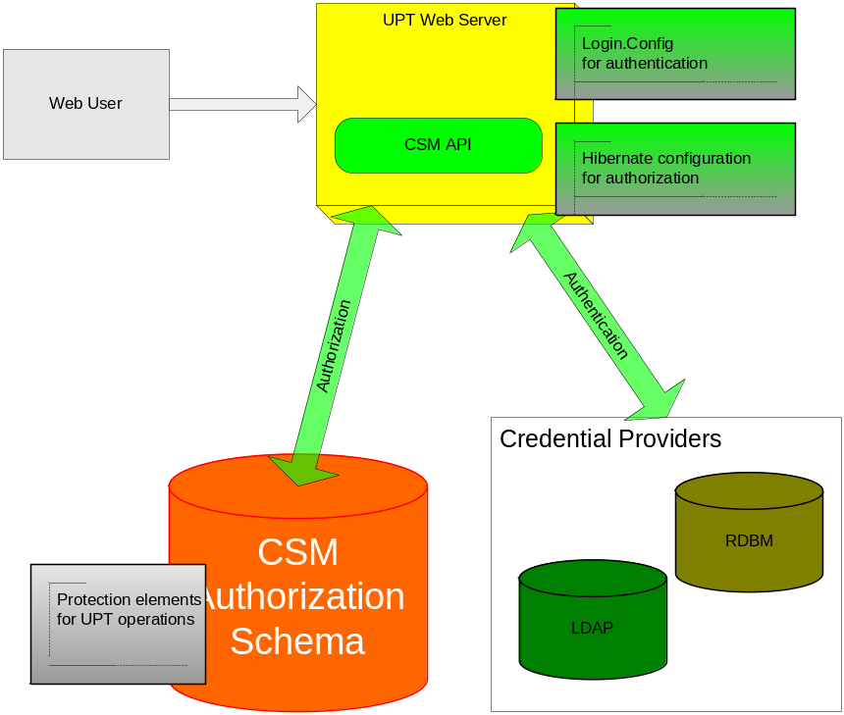
Figure 4.1 Architecture Diagram—Configurable UPT Operations
Configurable UPT operations are improvement features to authorize CSM Admin user performing UPT functionalities. These new features do not change authentication mechanism over any UPT deployment modes:
- Single installation, single schema
- Single installation, multiple schemas
- Local installation, local schema
These new features impact CSM authorization process in all tier/components, including:
- Authorization schema
- User Provisioning CSM API
- UPT web module

Implementation Consideration
This section details implementation approaches for the impacted tier/components for this release.

5.1 NIH Password Policy
The CSM AuthorizationManager interface provides all the authorization methods and services offered by the Common Security Module. It defines the operations which are required for the purpose of authorizing a user against the configured authorization data. It is the contract between any implementation classes and the Common Security Framework.
The CSM AuthenticationManager interface provides all the authentication methods and services offered by the Common Security Module. It defines the operations which are required for the purpose of authenticating a user. It is the contract between any implementation classes and the Common Security Framework.

Change Password

CSM API
The changePassword operation provided the user the ability to change his password. The Authentication manager API will be modified to provide this feature. This method with authenticate the user with the old password before changing the password and also validates the newpassword comply to the NIH password policy. The password expiry date is set the relevant value based on the configuration of the passwordExpiryDays property.
The following is the JavaDoc for the method
boolean changePassword (java.lang.String userName, java.lang.String password, java.lang.String newPassword,
java.lang.String passwordConfirmation) throws CSException, CSLoginException, CSInputException,CSConfigurationException

This method provides an ability for the user to change the password. It validates the user password before changing the password of the user
Parameters:
userName - CSM User Name a User
password - Password the user used to login or the old password
newPassword - New Password the user want to change to
passwordConfirmation - Reconfirmation. Same as the newPassword

Returns:
true if the user changePassword operation is successful ; false if the user is denied
Throws:
CSException, CSLoginException, CSInputException,CSConfigurationException

UPT Web Module
The UPT application will redirect to the change password screen when the user password is expired or the user is logs in for the first time after being created. The page will collect the old password, new password and the application context for which the user belongs. The user credentials will be posted to the CSM API changePassword() method to update the new password
The figure shows the change password UI fields for the UPT web modules
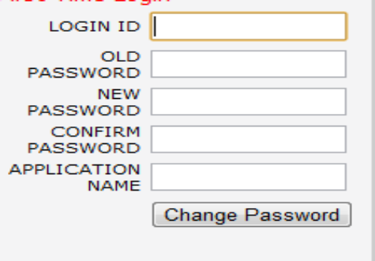

The new password should comply with the NIH password policy and should contain at least 8 characters a special character, a number and an Uppercase letter.
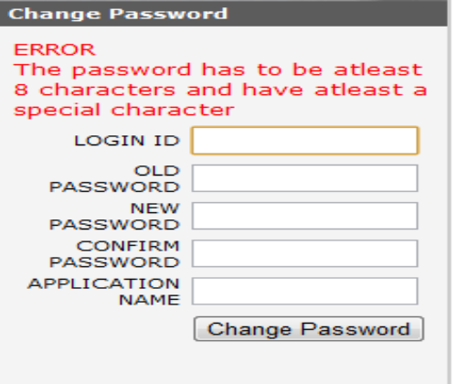
After successful login the page will be redirected to the login page.
CSM schema
A new table is added CSM_PASSWORD_HISTORY which holds the history of all the password that were changed. A new entry is made when the password is changed successfully. This enables the application to use a different password when the password is changed

Deactivate User

CSM API
The current implementation allows the admin user to remove any users for the system. When a user is removed his information is lost. With this implementation the user can be deactivated/activated by an Admin user. A flag in the user table will be added and will determine if the user is active. The modifyUser operation can be used to activate/deactivate the user
The following is the JavaDoc for the method.
public void modifyUser(User user) throws CSTransactionException;
This method provides an ability to update the user information along with activating/deactivating the users for the admin user
Parameters:
User - CSM user instance
Returns:
true if the user changePassword operation is successful ; false if the user is denied
Throws:
CSException, CSLoginException, CSInputException,CSConfigurationException

the authenticate method implementation will be modified to check for the user being active after authenticate the credentials. The deactivated users will throw a LoginException.
The signature of the authenticate method will remain the same and would not be modified as below
public Subject authenticate(
String userName,
String password)
throws CSException, CSLoginException,
CSInputException, CSConfigurationException, CSInsufficientAttributesException;

UPT Web Module
The UPT application can be used to activate a deactivated user and likewise deactivate a user. The activate/deactivate feature will be provided only to admin user. When deactivated, the user can not be authenticated and will be prompted a message with the same
The figure shows an active flag which can be set to false to deactivate a user.
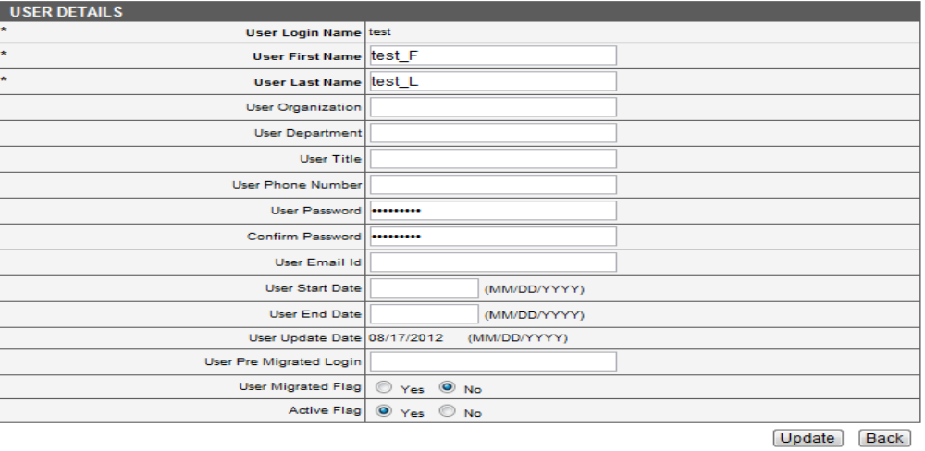

The figure shows a message when a deactivate users logs in to the system

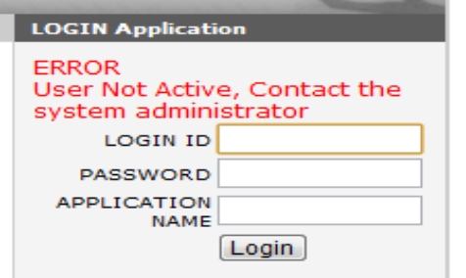
CSM schema
New column ACTIVE_FLAG will be added to the CSM_USER table to store the current status of the user. The Value TRUE indicates the user beeing active and FALSE indicates the user is deactivated and can not login.

NIH Password Policy
CSM API
The passwords for the user of CSM should comply with the NIH password policy. The CSM API will be modified to handle the requirement. A validatePassword() method with the provided to validate the unencrypted password has at least 8 character in length, a numeric character, a upper-case letters and a special character. This can be done by a regular expression. The validatePassword() is called from the changePassword() and hence can be private modifier. The login method is updated to check the password not expired.
the signature of the method
private boolean validatePassword(String password)
Parameters:
password - User unencrypted password
Returns:
true if the password is valid; false if the password does not comply
CSM schema
The PASSWORD_EXPIRY_DATE column will be added to the CSM_USER table to store the password expiry date.

Configurable Password Management
CSM API
The properties that define the security policy should be configured by the super admin of the UPT application. Apache configurations project of the apache project is leveraged to read and write the properties from database. A new singleton class gov.nih.nci.security.util.ConfigurationHelper will be added will be added to read and write these properties from the database.
The properties can be read by calling the static method getConfiguration() which returns an instance of DataConfiguration Object. The object is representation of the system properties and can be read and written using the getter and setter methods.

UPT Web Module
The UPT application can be used to configure the system properties for UPT application. The system properties can be viewed and edited by the superadmin
The figure shows the system properties used by the CSM which can be viewed/updated from UPT
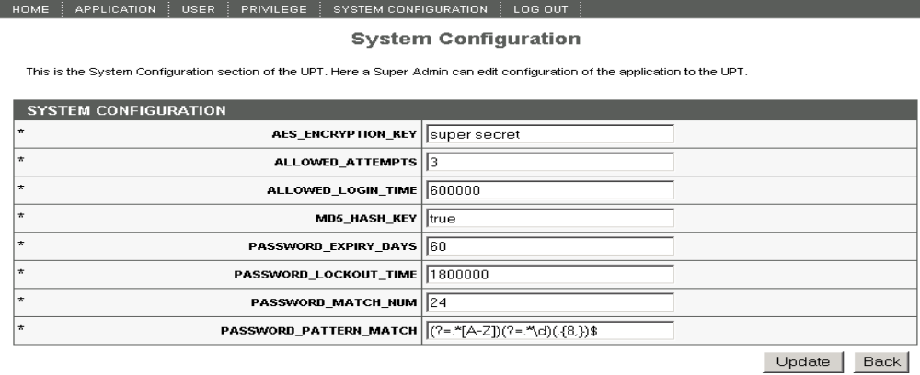

CSM schema
New table CSM_CONFIGURATION_PROPERTIES is added to hold the system properties. It contains columns PROPERTY_KEY and PROPERTY_VALUE with corresponds to key value pair for the system properties.

Encrypt PII
CSM API
As some the personal identifiable information like the user first name, last name is stored by the application, the information needs to be encrypted. The Application used the industry standard AES 256 bit encryption provided by the Bounty Castle for encrypting and decrypting this information. A new class AESEncryption with be added to handle the encryption and decryption. Once the class is instantiated, the below are signatures of the methods that are provided
This method can be used to encrypt
public String encrypt(String unencryptedString) throws EncryptionException {
Parameters:
unencryptedString - The unencrypted string
Returns:
AES encrypted string
This method decrypts the encrypted the sting
public String decrypt(String encryptedString) throws EncryptionException {
Parameters:
encryptedString - The encrypted string
Returns:
Decrypted string

Account lockout threshold setting
CSM API
The Account lockout threshold is currently defined in the XML file and the application constructs the LockoutManager during the startup. The Singleton class manages the Account lockout setting. The application needs to be restarted when these properties are modified. This behavior is modified with this feature by setting the threshold values of the LockoutManager object. A new Listener LockoutConfigurationListener is added which listens on the property value updates on the CSM_CONFIGURATION_PROPERTIES table using ConfigurationHelper.

UPT Web Module
The UPT application can be used to configure the Threshold values from the UPT application. The System Configuration will be enabled when the user logs in as the superadmin.
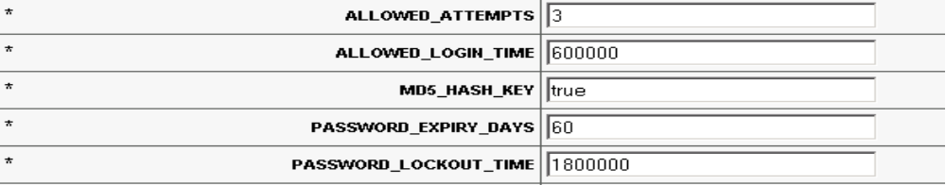

Schema Changes

Class Name: CSM_USER
Type: Table
This table store the users and the personal identifiable information of the user. Additional columns are added to the table to indicate the user being active , expiry date, and logging to the system for the first time.
Attributes
Attribute | Notes | Constraints and tags
PASSWORD_EXPIRED BOOLEAN  Public column | Indicates if the user password is expired | Default:  false
PASSWORD_EXPIRY_DATE DATE  Public column | Stores the date when the password is expired | Default:  null
FIRST_TIME_LOGIN BOOLEAN  Public column | Indicates if the user is logging in for the firsttime | Default:  True when user is created
ACTIVE_FLAG BOOLEAN  Public column | Indicates if the user is active | Default:  True

Class Name: CSM_PASSWORD_HISTORY
Type: Table
This table stores the users and the previous password information of the user. The unencrypted previous passwords are stored so that the user will forced to select a new one when the password is changed
Attributes
Attribute | Notes | Constraints and tags
CSM_PASSWORD_HISTORY_ID NUMBER  Public column | Id | Default:  Auto increment
LOGIN_NAME VARCHAR  Public column | CSM User Login name | Default:
PASSWORD VARCHAR  Public column | Stores the previous passwords for the user | Default:

Constrainsts
Method | Notes | Parameters
CSM_PASSWORD_HISTORY_ID Public | Primary key constraint | NUMBER

Class Name: CSM_CONFIGURATION_PROPERTIES
Type: Table
This table stores the system configuration properties for the application. It is a key value pair that can be used as Properties in the application.
Attributes
Attribute | Notes | Constraints and tags
PROPERTY_KEY VARCHAR | Key to indentify the Property | Not Null
PROPERTY_VALUE VARCHAR | Value of the Property for the key defined | Can be null

Migration
Currently, the passwords are encrypted using DES standard, since DES is considered vulnerable, the passwords and the Personally Identifiable Information (PII) will be encrypted using AES standard. The existing users and applications will need to encrypt the information using the AES standard. A migration utility will be provided to migrate the existing users. This utility will decrypt the existing passwords and encrypt with the new standard.

References
CSM 5.0 Scope Document, https://wiki.nci.nih.gov/display/caCORE/CSM+4.5+Scope+Document+-+DRAFT
CSM UPT 4.2.x User Guide, https://wiki.nci.nih.gov/display/caCORE/CSM+UPT+4.2.x+User+Guide
Appendix A. Maping between Release 5.0 Features and CSM/UPT Elements
The objective of the 5.0 version is functional improvements and usability improvements. These features will be implemented with minimum change of existing architecture and leveraging used technologies. This approach will benefit current CSM user with better backward compatibility and minor migration effort. Following table maps these features with existing CSM/UPT system elements.

Feature No. | Feature Name | Description | DB Schema Change | CSM API Change | UPT Change
4.5.1 | Configurable user provisioning operations | 1. Setup application level of control user’s access to user provisioning operations  2.Denny unauthorized user performing user provisioning operation | No | Yes,  1.Create protection element for each user provisioning operations  2.Only grant execute permission to authorized user | Yes,  Only enable web link/menu for authorized user
4.5.2 | User account activation | 1.Replace “delete” with “de-activate” user account function  2.Archive “de-activated” user’s account information  3.Re-activate a previously deactivated user account | Yes,  1.Additional column of user table to hold the status of user account  2.Current user with status of “active”  3.”Delete” user with status of “inactive” | Yes,  1. Modify “Delete” function to deactivate “active” user account  2. New API to activate “inactive” user account | Yes,  1.Display account status on user detail page  2.Add “account status” criteria to “Search User” operation  3. Add new operation to activate a user account
4.5.3 | Encryption of Personally Identifiable Information (PII). | Update CSM encrypt algorithm from DES to AES standard; AES has been effective as a Federal government standard on May 26, 2002. | No | Yes,  Additional APIs to encrypt and decrypt data to/from database | Yes,  UPT will use updated APIs
4.5.4 | NIH Password Policy enforcement. | Enforce NIH Password policy, http://datacenter.cit.nih.gov/interface/interface238/PW_policy.html | Yes,  - Record password age  - Archive password history | Yes,  1.Password validation  2.Password expiration | Yes,  1.Validate new password  2.Remind password expiration
4.5.6 | Configurable password management | Enable admin user to configure security policies | No,  Define security policy with configuration file | Yes,  1.validate password against security policy | Yes,  Apply UPT change with feature 4.5.6
4.5.7 | Account lockout threshold setting | Apply application level of control to user account lockout | No | No  The threshold is set with configuration file. | No
4.5.8 | Association navigation filtering | Current CSM only apply filter on searched object but ignore filter on the objects associated to the searched object | No | Yes,  Extend existing CSM to apply filter on the searched object as well as their associated objects | No,
4.5.9 | Extensible UPT web application | 1.support customizable and extendable actions and user interface 2.Include UPT within an existing web application | No | No | Yes,  1.Modularize UPT web components  2.Provide customizable deployment configuration  3.Setup extension framework

